Experiment – Prompt Engineering Techniques
Name :M.Dinesh
Rollno:2503a52374
Bachno:13
Question 1: Zero-Shot Prompting (Palindrome Number Program)
Write a zero-shot prompt (without providing any examples) to generate a Python function that checks whether a given number is a palindrome.
Task:
- Record the AI-generated code.
- Test the code with multiple inputs.
- Identify any logical errors or missing edge-case handling.
Promt : Using zero-shot prompting, write a Python program to check whether a number is a palindrome.
input:
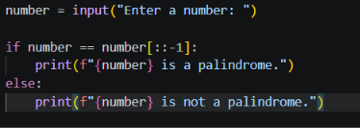

Output:
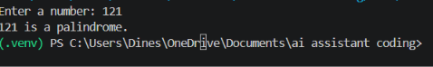12

Question 2: One-Shot Prompting (Factorial Calculation)
Write a one-shot prompt by providing one input-output example and ask the AI to generate a Python function to compute the factorial of a given number.
Example:
Input: 5 → Output: 120
Task:
- Compare the generated code with a zero-shot solution.
- Examine improvements in clarity and correctness.

Promt: Using one-shot prompting, write a Python function to calculate factorial.

Example: 5 → 120
Input:
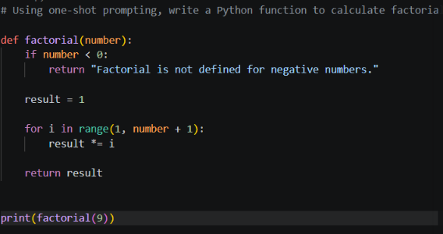
Output:
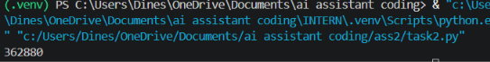

Question 3: Few-Shot Prompting (Armstrong Number Check)
Write a few-shot prompt by providing multiple input-output examples to guide the AI in generating a Python function to check whether a given number is an Armstrong number.
Examples:
- Input: 153 → Output: Armstrong Number
- Input: 370 → Output: Armstrong Number
- Input: 123 → Output: Not an Armstrong Number
Task:
- Analyze how multiple examples influence code structure and accuracy.
Test the function with boundary values and invalid inputs
Promt: Using few-shot prompting, write a Python program to check whether a number is an Armstrong number.

153 → Armstrong Number
370 → Armstrong Number
123 → Not an Armstrong Number
Input:
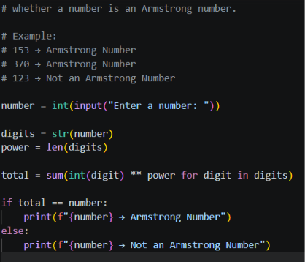
Output:
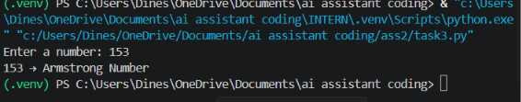
Question 4: Context-Managed Prompting (Optimized Number Classification)
Design a context-managed prompt with clear instructions and constraints to generate an optimized Python program that classifies a number as prime, composite, or neither.
Task:
- Ensure proper input validation.
- Optimize the logic for efficiency.
- Compare the output with earlier prompting strategies.

Promt: Using context-managed prompting, write an optimized Python program to classify a number as prime, composite, or neither. Include input validation.
Input:
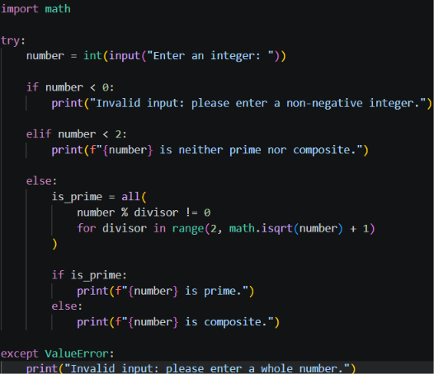
Output:
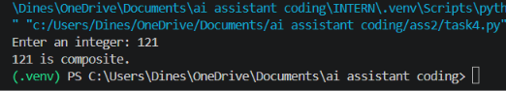

Question 5: Zero-Shot Prompting (Perfect Number Check)
Write a zero-shot prompt (without providing any examples) to generate a Python function that checks whether a given number is a perfect number.
Task:
- Record the AI-generated code.
- Test the program with multiple inputs.
- Identify any missing conditions or inefficiencies in the logic.

Prompt:
Using zero-shot prompting, write a Python program to check whether a number is a perfect number.
Input:
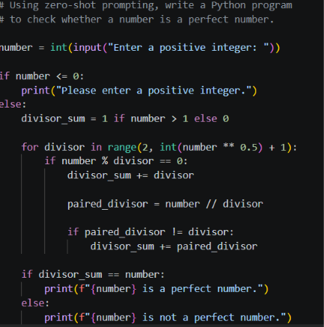
Output:
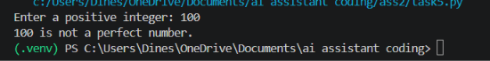
Question 6: Few-Shot Prompting (Even or Odd Classification with Validation)
Write a few-shot prompt by providing multiple input-output examples to guide the AI in generating a Python program that determines whether a given number is even or odd, including proper input validation.
Examples:
- Input: 8 → Output: Even
- Input: 15 → Output: Odd
- Input: 0 → Output: Even
Task:
- Analyze how examples improve input handling and output clarity.
Test the program with negative numbers and non-integer inputs
Promt:
Using few-shot prompting, write a Python program to check whether a number is even or odd with input validation.

8 → Even
15 → Odd
0 → Even
Input:
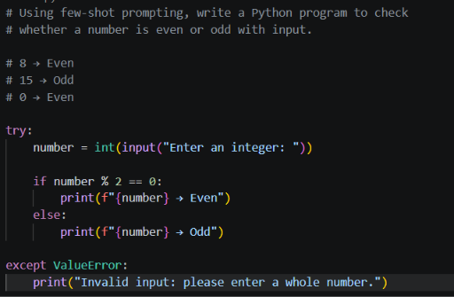
Output:
